2024/25 – Manager Matchday Administration

This document is aimed at assisting managers and Club Fixture Secretaries with completing all aspects of arranging fixtures / reporting results.

All dates based on fixtures taking place on Sundays.

Arranging Fixture

By Tuesday evening at the latest, managers / Club Fixture Secretaries are required to advise the opposition team official (and match official if allocated) the following details.…

- Venue and directions to venue.
- Kick off time.
- Kit colours including goalkeeper.

This information can be sent via sms or email and you should request confirmation from opposition manager that details have been received. If a team has not received match details, then they are to contact their allocated League Fixture Secretary.

Please note, teams are also required to update FA Full-Time with kick-off time.

Reporting Results

By 17:30 on a Sunday evening, the result of each match needs to be notified by both teams by updating FA Full-Time. The result includes postponements and abandonments.

FA Full-Time can be updated by either responding to the sms message or by updating FA Full-Time.

For evening fixtures, results must be notified by 21:30

Completing Match Returns

Clubs/teams have until 5 days after the fixture to complete the match return on FA Full-Time. For Sunday fixtures, this means a match return must be complete by Thursday evening.

The match return must include the following information:

- Player names (starting team and substitutes only. Do not include players not in match day squad).
- FA marks.
- League marks. (see page 7)
- Referee marks.
- Red & Yellow cards.
- Sin bins.

NB Home teams are also required to record the name of the referee.

Please make sure match returns are not only complete but also accurate.

Guide to completing FA Full-Time match return.

Note: The League do not advise use of the FA Matchday app to complete your match return. Despite what the FA may say, the app does not integrate with FA Full-Time correctly.

Accessing/Signing into FA Full-Time

The following roles can get access to FA Full-Time:
Team Manager, Team Coach (assistants of these roles) or Team Secretary.

Full-Time Login

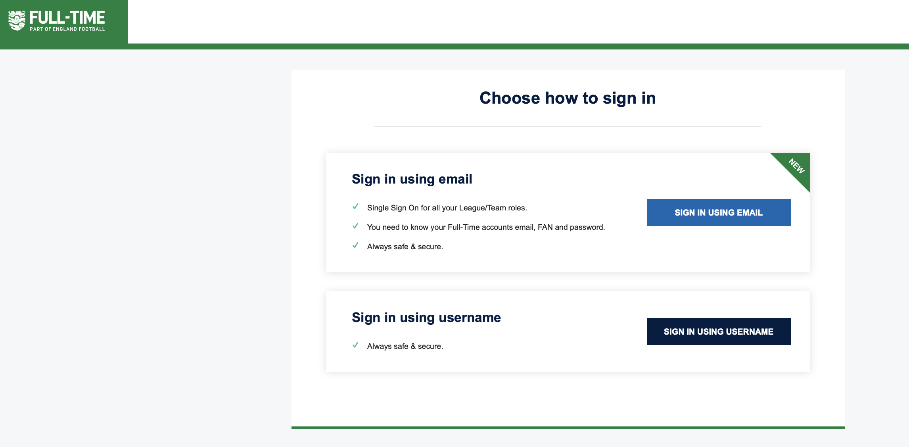

Finding where to input your results

When you login, the first page you will see will be "Admin Home". From here you can either click the "Results" tab along the top or if you don't have access to this, the "Enter Results" box within the middle of the screen.

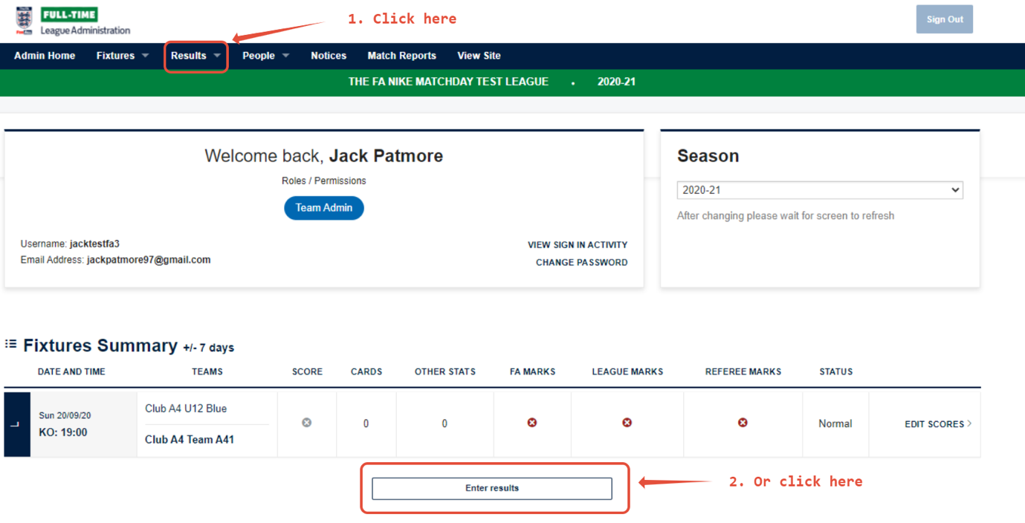

Entering your Match Stats/Results

- Firstly, enter your match result using the input boxes and then click "Update" to save this.

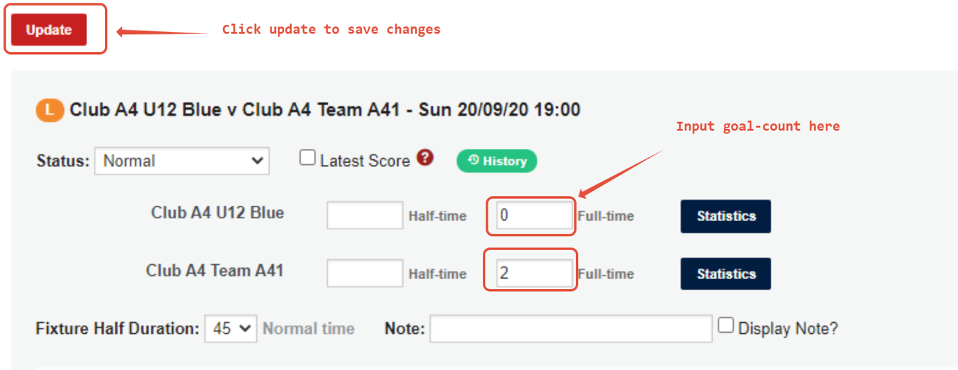

2. Then click "statistics" after navigating to the FA Full-Time site results tab.
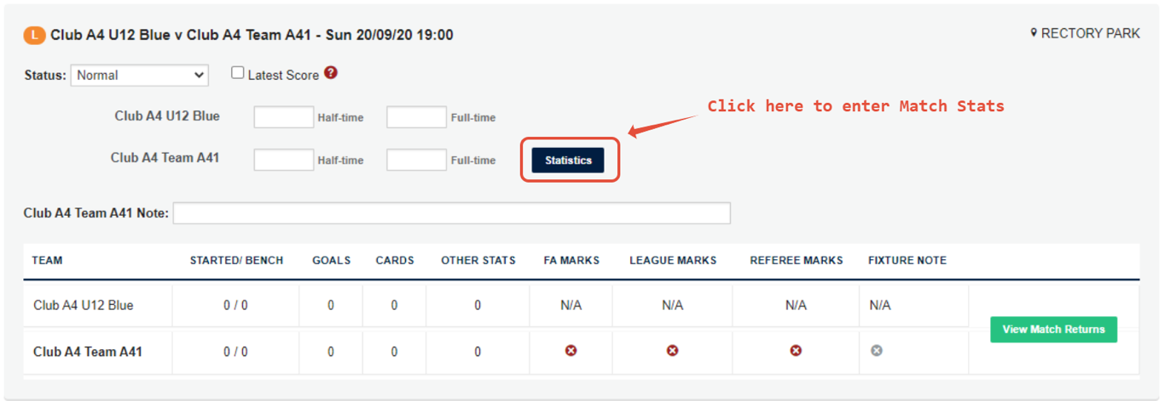

On the first page you will need to input the name and marks for the Match Official
Your FA Marks must be completed before you can progress to "Player Statistics" and enter your final results sheet.

Please note: If you enter a mark of 60 or below you will need to leave reasons for the mark within the comments box. You are also required to send a report to the League Referee Secretary.

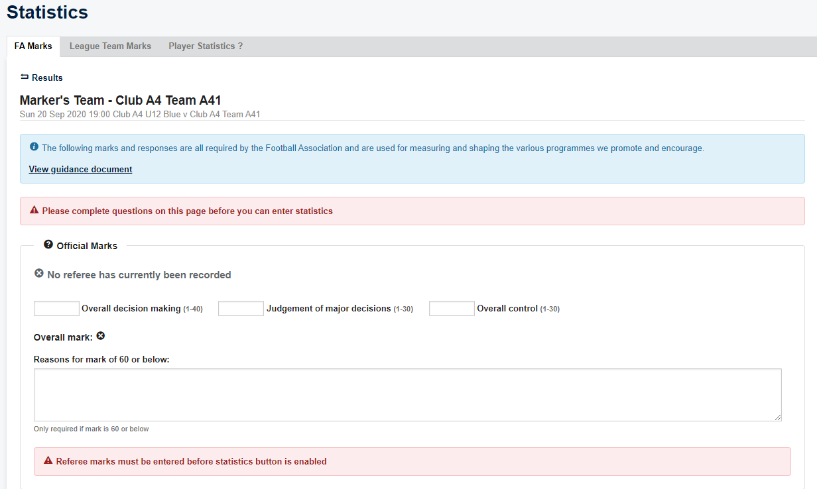

RESPECT Marks
After completing referee marks, you will need to complete your RESPECT marks.

These marks are compulsory to be filled in and help The FA and the league assess behaviour within grassroots football.

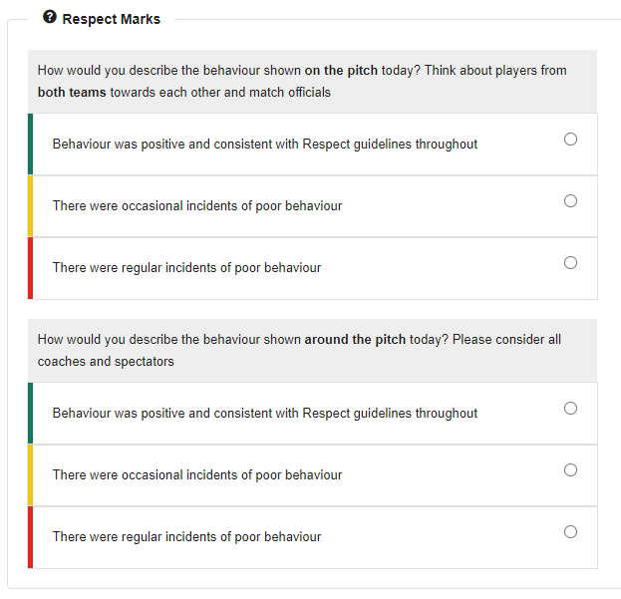

Pitch Marks

Finally, you will need to complete the pitch marks.

Please note: Remember to click "Update" to save your marks
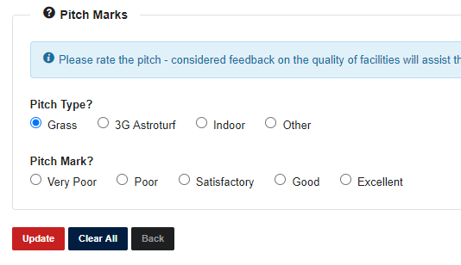

LEAGUE TEAM MARKS

Next tab says "League Team Marks" which will need to be completed.

These are questions set by the League

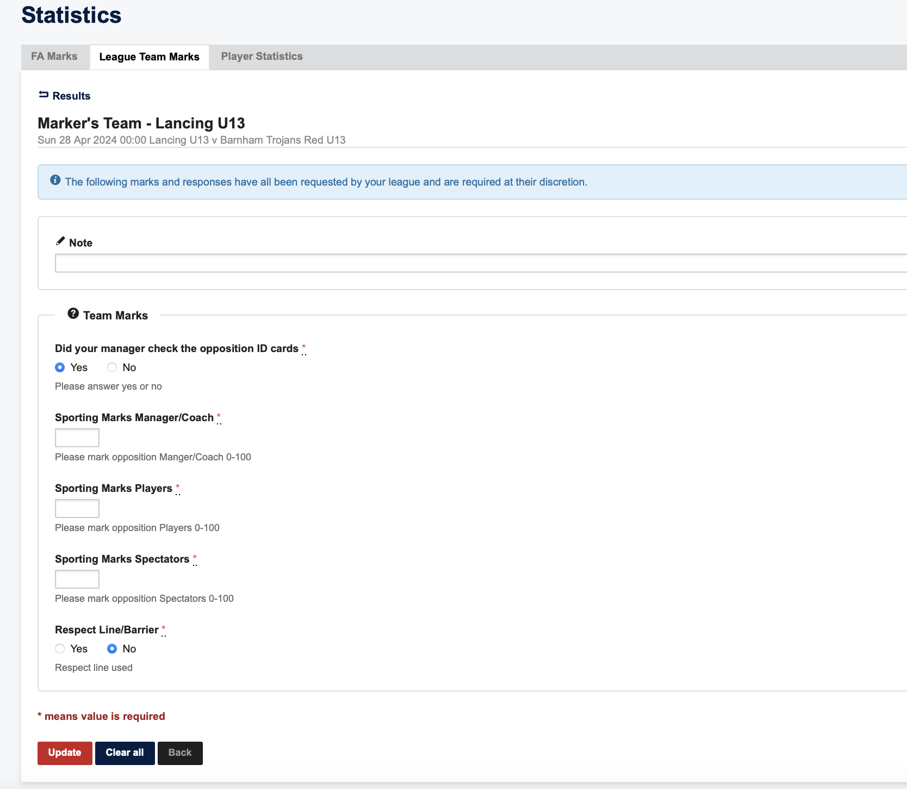

When awarding marks, teams are required to mark from 1 to 5.

1 = Very Poor, 2 = Poor, 3 = Satisfactory, 4 = Good, 5 = Excellent

A mark of 1 will require a written report to the League via the Club Secretary

Please note that the legend under “Range Lowest” and “Range Highest” will still say “Marks may be in any range from 0 (lowest) to 100 (highest)”. This is FA default and cannot be changed

PLAYER STATISTICS

Finally, you will need to complete your player statistics.

From this page you will need to "check" your starters, substitutes and other match stats such as goals, red and yellow cards, sin-bins.

Please note: If any players are missing from your team sheet and aren't available to complete stats for, please speak to the league.

There are also two options at the top, “Switch to Quick Stat Entry” and “Switch to Simple View”.

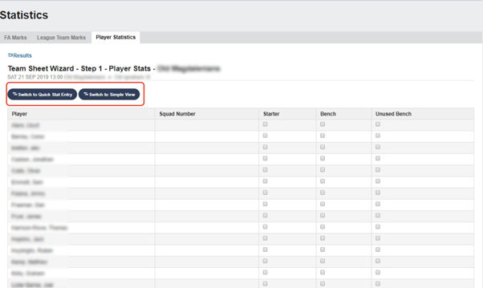

Quick Stat Entry

Selecting the quick stat entry allows you to enter the starting line-up, bench and unused bench players along with the captain, goal scorers, penalties, own goals, yellow and red
cards, sin-bins.

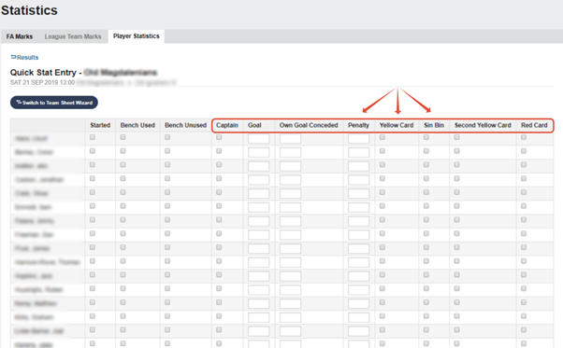

*Please note that if a number is entered in the penalty box (For example 1) and the penalty is scored then a 1 still needs to be entered in the goal box otherwise it will register to the penalty as missed.

Simple View
Switching to simple view allows you to enter the players name type of stat you would like to enter for them and the minute the statistic occurred. If you would like to add assists you can do so by entering the players name in the assist box below the stat box.
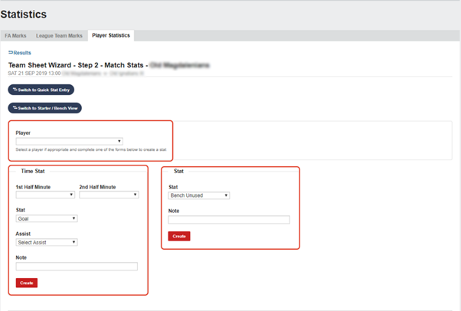

Once you've clicked "Update Stats for players" these statistics will be saved and an overview will be produced at the bottom of the page of the statistics you have entered

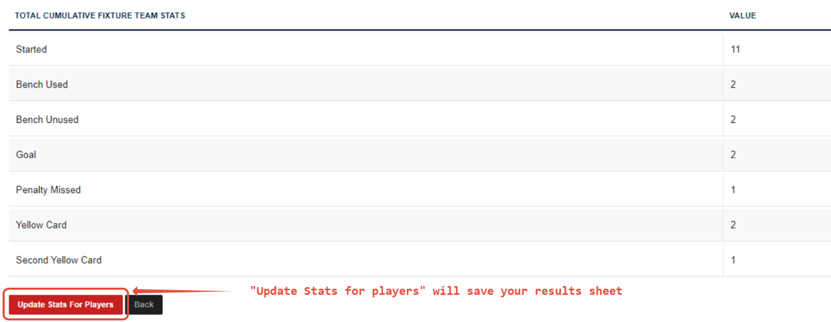

Viewing your Summary

You can view your match results summary by clicking "Results" and then "View Match Returns"

